Redundant Pipe Organ M0222
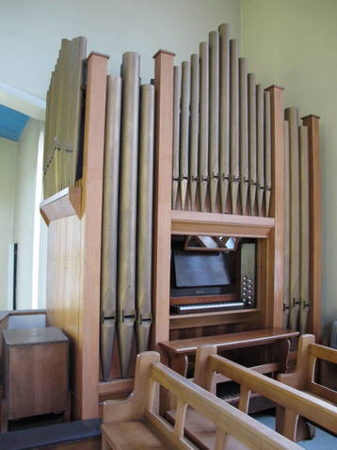
H J Nelson c.1935

St Francis Roman Catholic Church
Stotts Road, Walkergate, Newcastle upon Tyne
NE6 4UH NZ293657

NPOR G01669

1 manual and pedals
7 speaking stops

TP key action
Mechanical drawstop action

Dimensions: 12' 9" high; 9' 2" wide; 5' 00" + 16" pedal extension

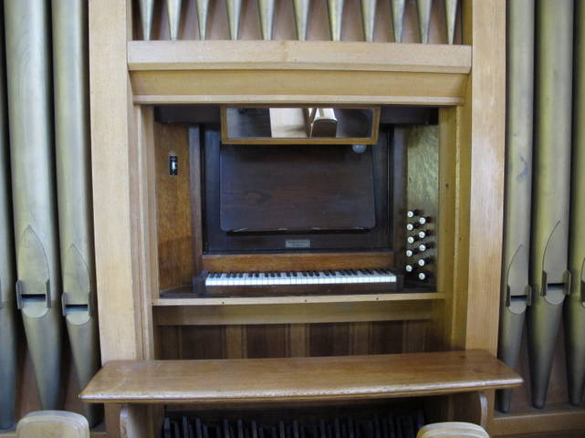
Keyboard 58 notes
Pedal 30 notes

Great Open diapason 8
Dulciana 8
Rohr flute 8
Principal 4
Wald flute 4

Pedal Bourdon 16
Bass flute 8

Couplers Great to Pedals
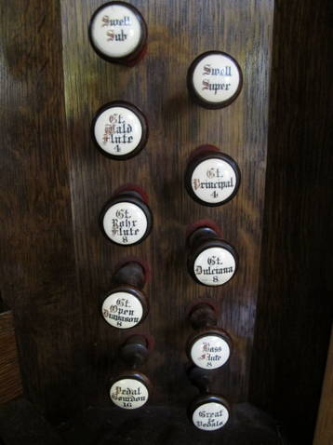
Great sub
Great super

Oak casework and stool

B.O.B. blower

Organ in good playing order, maintained by Brian Brighton, ex-apprentice of J.H. Nelson.
Some alterations by H.E.Prested probably to pneumatic tubing.

The sound is particularly rich with diapason chorus, giving a good lead for 200 congregation.
The sub and super couplers give added strength and variation to sounds produced.

- Notes John Hart
The church is to close in the next few weeks when the organ will be available.

Enquiries to the church contact, please.

Buyer makes removal arrangements.

Seller is not responsible for errors.

Organ contact
John Hart
Tel. 01325 312 960
Email: johnhart1@btinternet.com

Church contact
Fr. Michael Conaty M.B.E.
Tel. 0191 262 3817
Email: mconaty@dsl.pipex.com

