Redundant Pipe Organ M0211

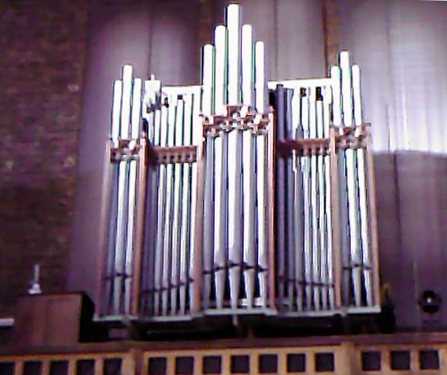
Rothwell 1905

St Agatha’s Roman Catholic Church
Market Way, Landport, Portsmouth, Hants UK

NPOR D06832

2 manuals and pedals
22 speaking stops

Tubular Pneumatic key and stop action

Compass 56/30

Dimensions
Width c.12ft
Depth c.10?ft
Height c.15ft

Pedal
Double Diapason 16
Bourdon 16
Bass Flute 8
Trombone 16

Great
Double Diapason 16
Open Diapason 8
Stopped Flute 8
Dulciana 8
Principal 4
Harmonic Flute 4
Fifteenth 2
Mixture III
Trumpet 8

Swell
Bourdon 16
Open Diapason 8
Rohr Flute 8
Viol D’Orchestre 8
Voix Celeste 8
Principal 4
Fifteenth 2
Cornopean 8
Oboe 8
Tremulant

Swell to Great
Swell to Pedal
Great to Pedal

3 combination pedals to Great and Pedal
3 combination pedals to Swell

Balanced Swell pedal at RHS

Latch-down pedal for Tremulant

The Rothwell organ came from St Andrew's Church, Royal Marine Barracks, Eastney, Portsmouth and was partially restored by Mander on installation about 10 years ago.

The organ is sited in the west gallery. For a photo of the organ loft see –
http://www.geograph.org.uk/photo/2069851

The main case contains the Great and Swell divisions. The Pedal pipes and blower are in the tower arcade.

The organ is played from a detached drawstop console to the south side of the main case.

The organ is playable but further renovation is needed.

It is now unwanted and immediately available.

Enquiries to the church contact, please.

Buyer makes all arrangements for dismantling, packing and transport.

Care is taken to provide correct information but the seller is not responsible for errors.

Church Contact:
Chris Whatley
Secretary St Agatha’s Trust
Email: c.whatley197@btinternet.com

