Redundant Pipe Organ M0210
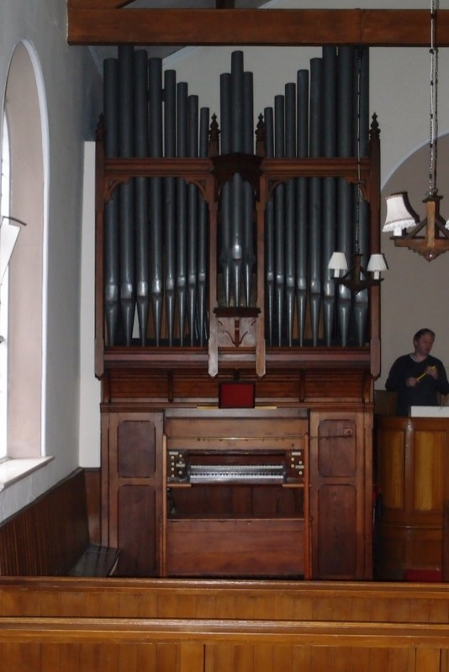
Benson (1881-1921)

Over Alderley Methodist Church
Birtles Lane Over Alderley Macclesfield Cheshire
SK10 4RZ SJ 873 758

NPOR G00683

2 manuals and pedals

8 speaking stops

Compass 58/30

Tracker/Mechanical action throughout

Dimensions
Width 7ft 6ins
Depth 6ft (including the front overhang
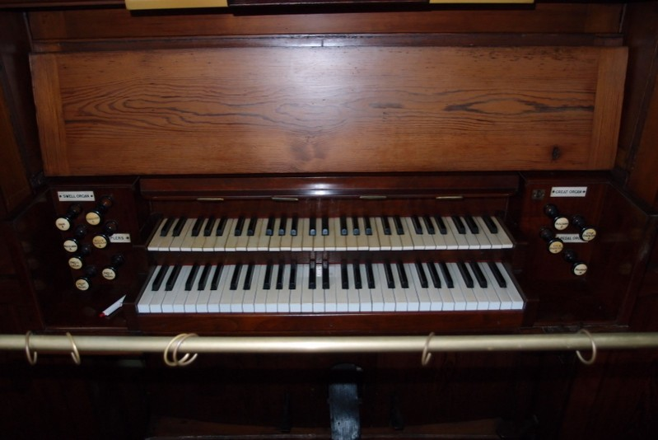
and the rear projecting box)
Height c.15ft

Stop List

Great
Open Diapason 8
Stop Diapason 8
Dulciana 8

Swell
Violin Diapason 8
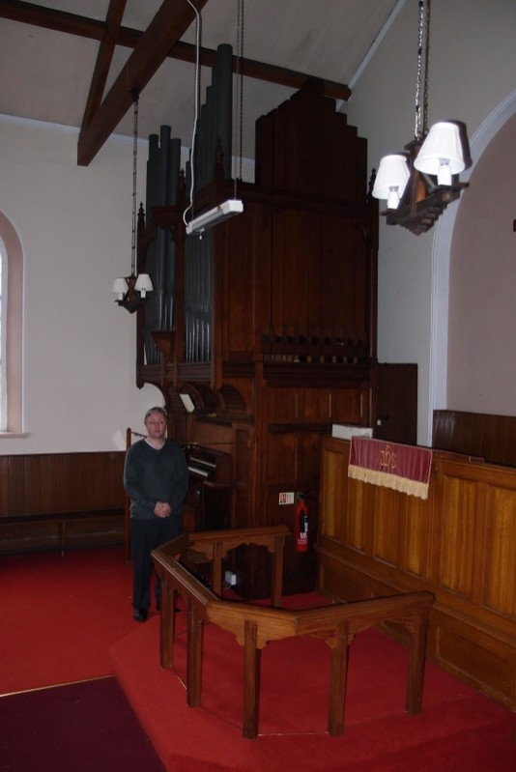
Salicional 8
Gemshorn 4
Oboe 8

Pedal
Bourdon 16

Swell to Great
Swell to Pedal
Great to Pedal

Central balanced swell pedal.

A hitched swell mechanism is also evident but presumed disconnected.

Pedals parallel flat.

This is reported to be a “nice organ”.

The church closed in March 2011.
The organ is redundant, playable and immediately available.
Enquiries to the church contact, please.

Buyer makes all arrangements for dismantling, packing and transport.

Care is taken to provide accurate information but the seller is not responsible for errors.

Church Contact:
Rev Andrew Halstead
Tel. 01625 424361
Email: halstead7@hotmail.com

