Redundant Pipe Organ M0219
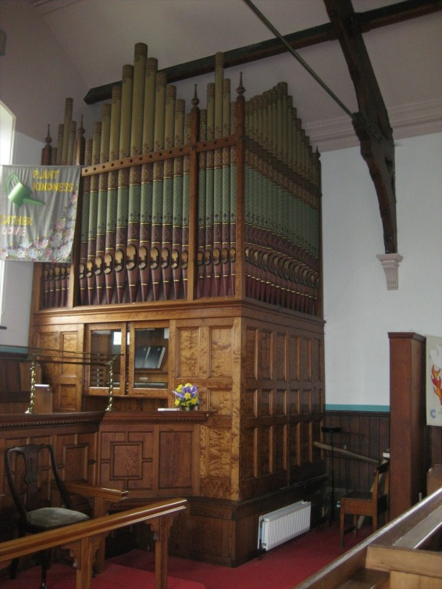
James Conacher & Sons c.1886

Ingbirchworth Methodist Church
Huddersfield Rd, Ingbirchworth, Sheffield,
South Yorkshire UK S36 7GF SE 222 060

BIOS Historic Organ Certificate Grade II

NPOR Index G00694

2 manual and pedals
10 speaking stops

Action
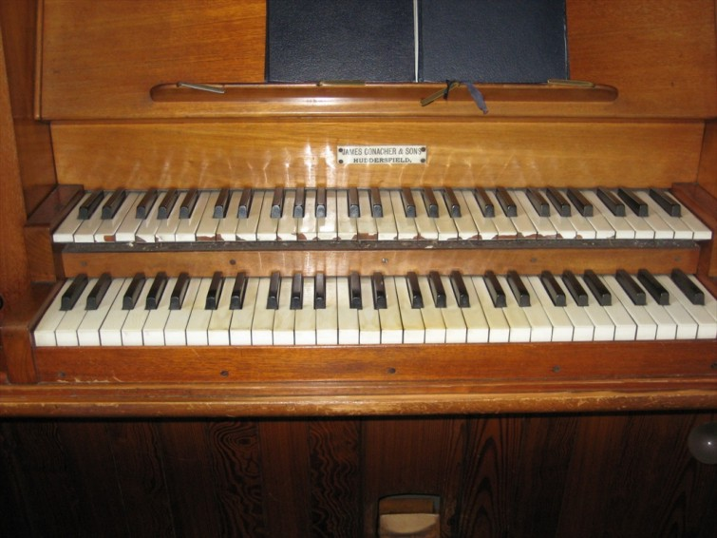
Tracker manuals
TP pedals
Mechanical drawstops

Dimensions
Width c.9 ft
Depth c.8 ft
Height c.14 ft

Pedal | Key action TP Stop action Me Compass-low C Compass-high f1 Keys 30
 | 1 | Bourdon | 16
Great | Key action Tr Stop action Me Compass-low C Compass-high g3 Keys 56
 | 2 | Open Diapason | 8
 | 3 | St. Diapason & Clarabella | 8
 | 4 | Dulciana | 8
 | 5 | Flute Harmonic | 4
Swell | Key action Tr Stop action Me Compass-low C Compass-high g3 Keys 56 Enclosed
 | 6 | Violin Diapason | 8
 | 7 | Rohr Flute | 8
 | 8 | Salicional | 8
 | 9 | Principal | 4
 | 10 | Oboe | 8

Compass 56/30

Pedals Parallel Flat
Central balanced swell pedal

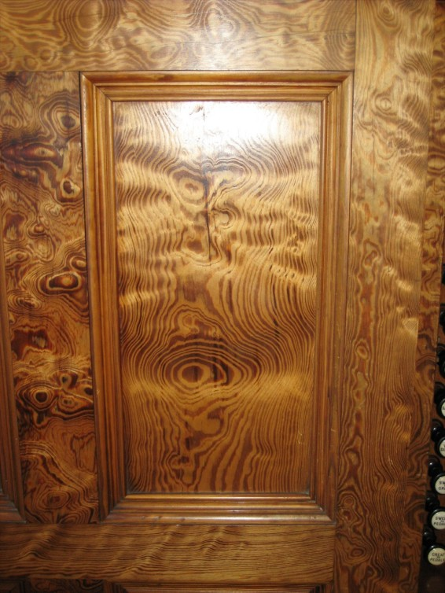
4 combination pedals
Central balanced swell pedal.

Chromatic slider soundboards.
Single reservoir. Double rise. Inverted fold.
Pumping handle and wedge bellows in place – and working.

Ivory key tops worn.
Key fronts in poor condition.

Attractive pitch-pine case and panelling with walnut painted pattern

Display flats 5+11+5
Side pipes are dummies
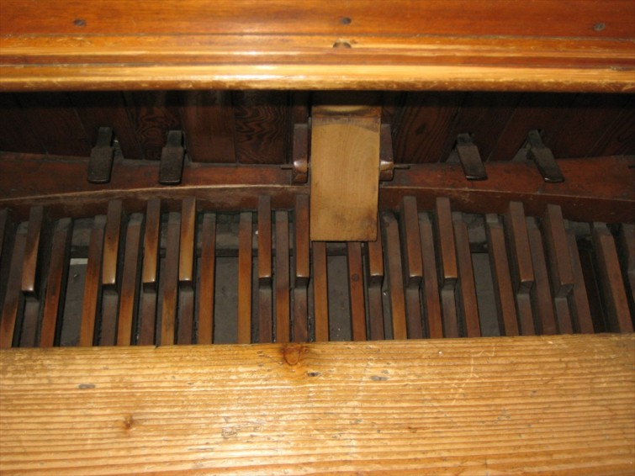
Robust Diapasons and full, clear Flutes

Dulciana bottom 8ve grooved to Clarinet Gedact
Salicional bottom 8ve grooved to Flute
Oboe full compass

The church is shortly to close when the organ will become redundant and is available after
9th September 2012

Seller is not responsible for information errors.

Buyer makes all dismantling and transport arrangements.

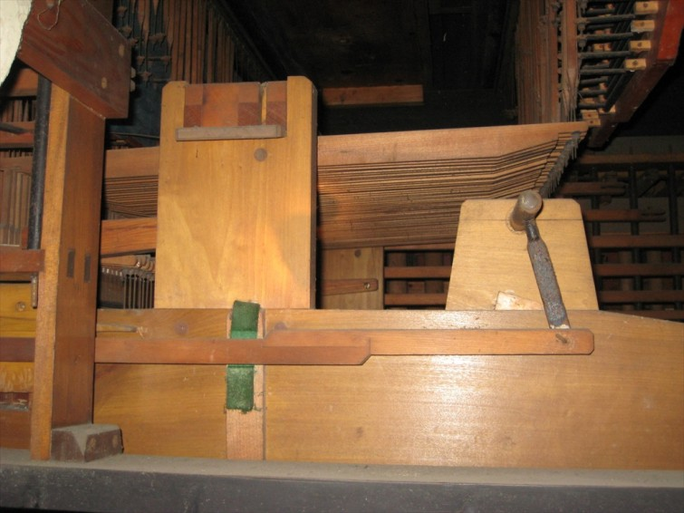
Offers and enquiries to the church contact, please.

Tuner:
Andrew Carter, Wakefield, Organ Builder
Tel. 01924 822 368
Email: Email@ajcarterorganbuilder.co.uk

Church Contact:
Arthur Holmes
Tel. 01226 762 575
Email: holmesingbirchworth@hotmail.co.uk

