Redundant Pipe Organ M0207
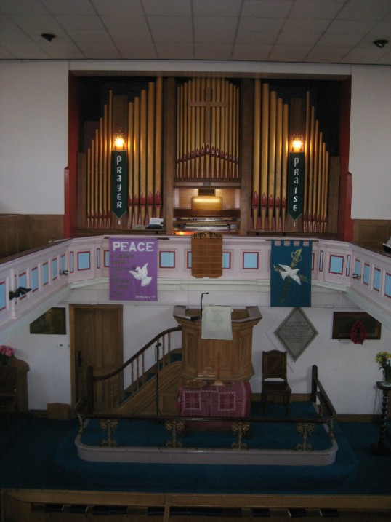
James Cole 1875

Longsight Methodist Church
Harwood Bolton Lancs. BL2 3HX

NPOR G00579

2 manuals and pedals
19 speaking stops

Electro-pneumatic manual action
Electric stop action

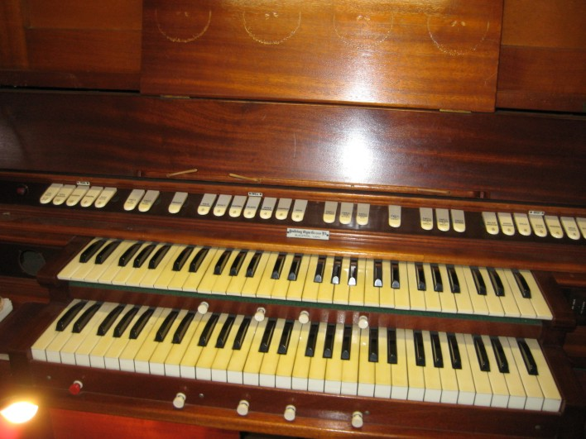
Dimensions
Width c17 ft
Depth c10 ft
Height c17 ft

Compass 56/30

The organ is sited at gallery level with the Swell box
against the left wall.

Pedal
Sub Bass 32
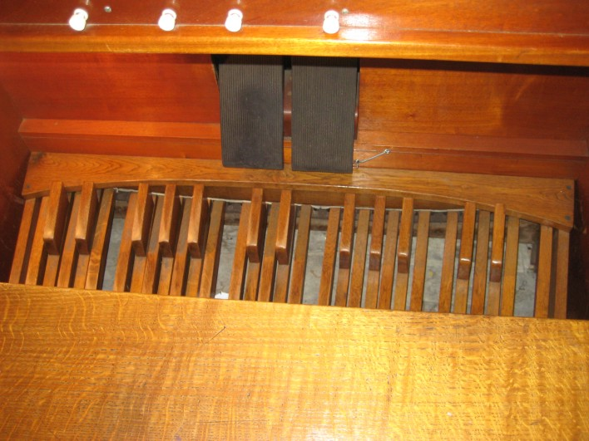
Open Diapason 16
Bourdon 16
Bass Flute 8
Principal 8

Great
Major Open Diapason 8
Minor Open Diapason 8
Rohr Flute 8
Dolce 8
Principal 4
Wald Flute 4
Fifteenth 2

Swell
Violin Diapason 8 lower octave grooved into Ged
Gedacht 8
Salicional 8 lower octave grooved into Ged
Celeste 8 TC
Geigen Principal 4
Cornopean 8 56 pipes
Oboe 8 56 pipes

Great Dolce and Rohr Flute appear to be the same rank.

Swell to Pedal
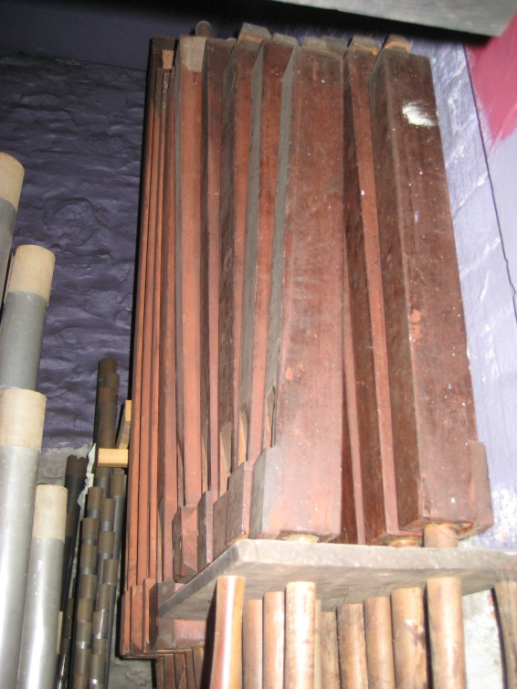
Swell to Great
Swell Octave to Great
Swell Suboctave to Great
Swell Octave
Swell Suboctave
Swell Unison Off
Great to Pedal
Great Octave

4 thumb pistons for each of Swell and Great

Electric blower

Single rise reservoir

Crescendo pedal

Balanced Swell pedal

Oak console frame, pedals and bench.

The organ was converted to Electro Pneumatic / Electric action 1951 when sub and super octave couplers were fitted. There are no extension pipes.

The building is to close at Easter 2012 when the organ will become available.

Enquiries, offers and expressions of interest to the church contact please.

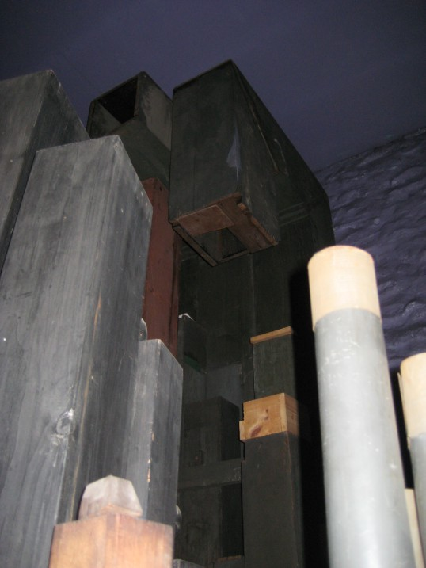
Buyer makes all arrangements for dismantling, packing and transport.

Care is taken to provide correct information but the seller takes no responsibility for errors.

Contact:
Rev Ian Smart
Tel. 01204 30 61 09
Mob. 07875 569 225
Email: ian@karenandian.com

