Redundant Pipe Organ M0217

Laycock & Bannister 1908
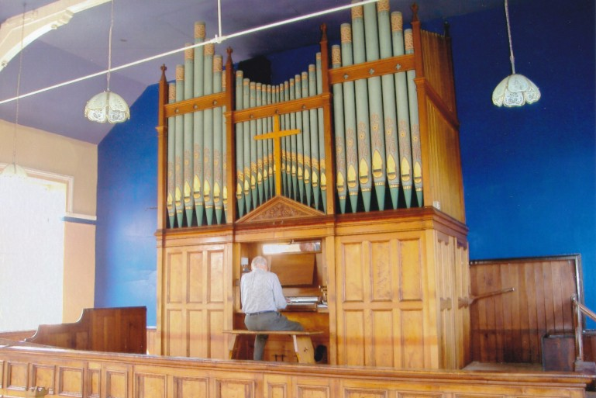
Harecroft Methodist Church
Haworth Road Harecroft Wilsden
Bradford W Yorks
BD15 0BP SE 082 356

NPOR G01425

2 manuals and pedals
9 speaking stops
Tracker action to manuals
Pneumatic action to pedals
Mechanical stop action

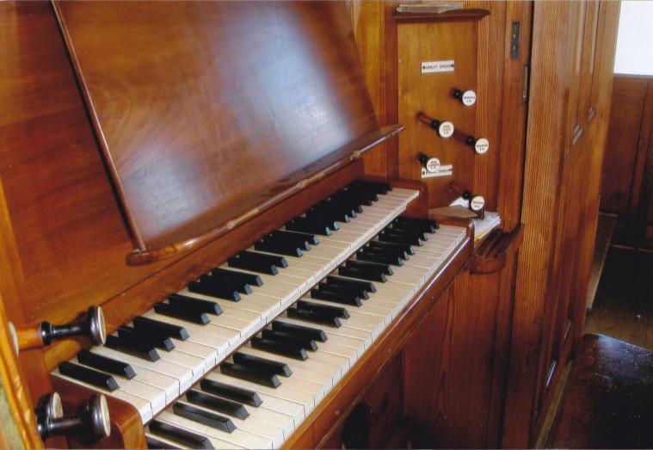
Compass 58/30

Width 3.72m
Depth 1.91m
Height 5.50m

Offset balanced swell pedal
4 combination pedals

The church has had to close and the organ is redundant. It is immediately available.

The instrument has been well maintained and is in good playing condition and well tuned.
The pump handle visible in the photograph, is not connected.

A slight running is evident on the Great but there is almost none on the Swell.

The electric blower is downstairs and is very quiet at the console.

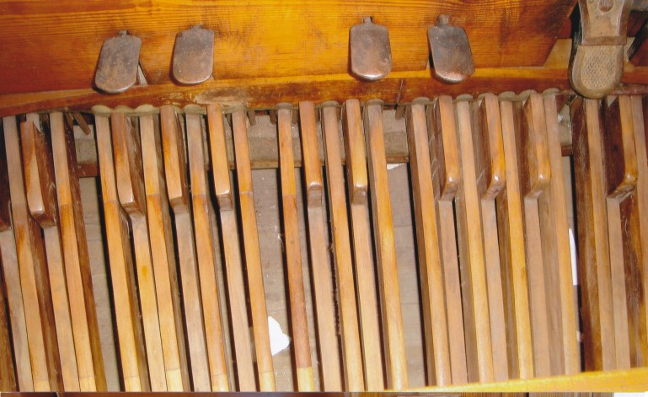
An impressive sounding instrument.

Great
Open Diapason 8
Holhflote 8
Dulciana 8
Principal 4

Swell
Violin Diapason 8
Rohrflote 8
Salicional 8
Oboe 8

Pedal
Bourdon 16

Swell to pedal
Swell to Great
Great to Pedal

4 combination pedals
Offset balanced swell pedal

Buyer makes all arrangements for dismantling, packing and transport.

Care is taken to provide accurate information but the seller accepts no responsibility for errors.

Enquiries and offers to the church contact please.

Organ Contact:
David Wilks
Tel 0113 293 2960
Email: david.wilks57@ntlworld.com

Church Contact:
Mr J Waddington
Tel. 01535 647 040

