Redundant Pipe Organ M0215

Harrison & Harrison 1897
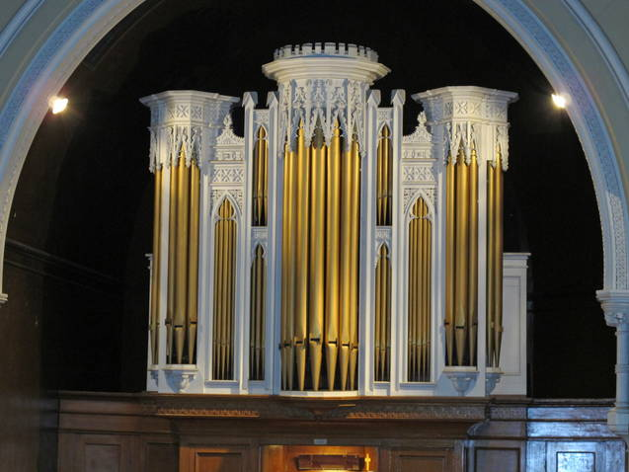
Dilston Road Methodist Church
Callerton Place Newcastle Upon Tyne
Tyne & Wear NE4 5NQ

NPOR R00634

2 manuals with pedals
20 sp stops

Tracker / Mechanical throughout

Compasses 30/58

Dimensions:
Width 13' 4"
Depth 17' 4", including 18" for pedal board extension
Height 23' The white case - the height above impost level is 15'.

See history in N04104, K00251, K00252, K00253

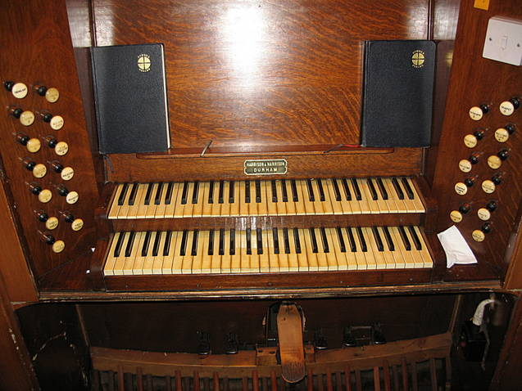
Pedal
Open Diapason 16
Bourdon 16
Flute 8

Great
Contra Gamba 16
Open Diapason 8
Dulciana 8
Hohlflote 8
Principal 4
Harmonic Flute 4
Fifteenth 2
Trumpet 8

Swell
Bourdon 16
Viola 8
Lieblich Gedackt 8
Salicional 8
Voix Celestes 8
Principal 4
Mixture III 15.19.22
Horn 8
Oboe 8
Tremulant

3 composition pedals to Great
2 composition pedals to Swell
balanced swell pedal

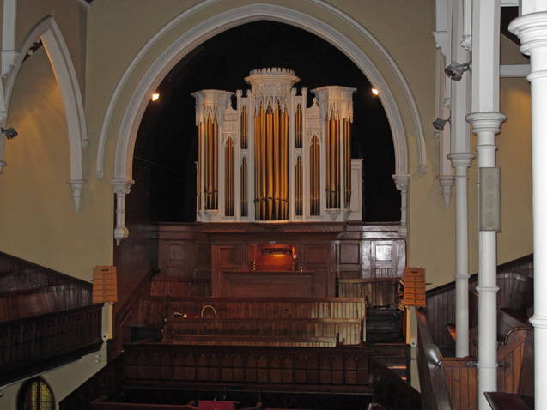
Outwardly it is a decent largish Harrison instrument of 1897.

Sited in the "traditional" raised Methodist position behind the pulpit and communion table, with spectacular ornate old case (said to be from central Newcastle - Nicholson, or even older, perhaps Bruce of Edinburgh - cf Chopwell and Wingate). The Ward additions were insertions of "prepared for stops".

There is an unexplored possibility that it is a rebuild, or use of old ranks by Harrison.
- Richard Hird

The organ is in superb playing condition - it is tuned twice a year by Harrison & Harrison.

The church is hoping to sell the building to an existing worship group who have no use for a pipe organ.

The organ will be available when the sale of the building is concluded. Please lodge enquiries with the church contact.

Care is taken to provide accurate information but the seller is not responsible for errors.
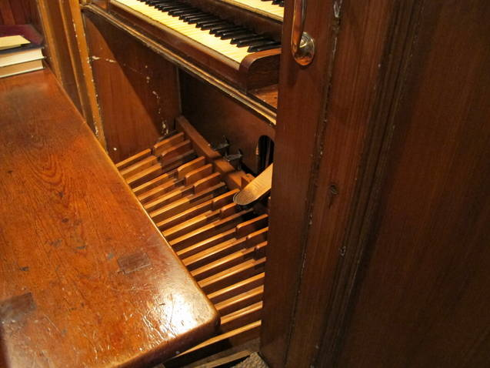
Buyer makes all arrangements for dismantling, packing and transport.

Organ contact:
John Hart
Tel. 01325 312 960
Email: johnhart1@btinternet.com

Church contact:
Malcolm Forster
Tel. 0191 285 8317
Mob. 07889 473 244

