Redundant Pipe Organ M0221

W G Vowles c.1890

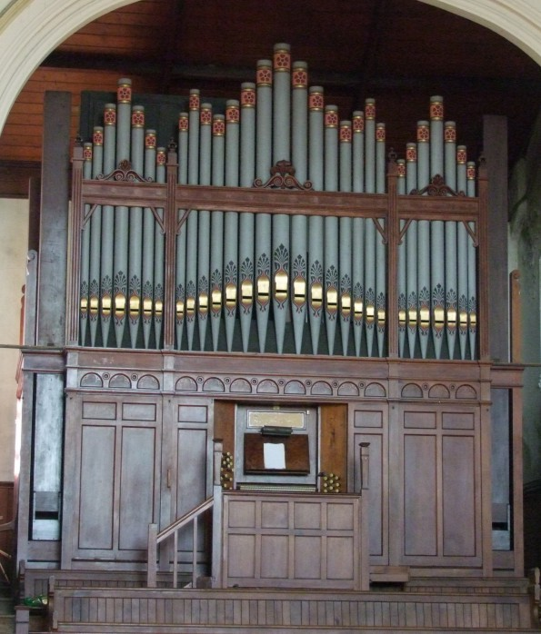
Porthkerry Road Methodist Church
Porthkerry Rd Barry Cardiff S Glam CF62 6LF

NPOR G00519

2 manuals and pedals
22 speaking stops

Pneumatic action to manuals and pedals
Mechanical drawstop action

Compass 56/30

Dimensions
Width 5.2m
Depth 2.4m
Height 5.6m

Specification

Great Swell
Open Diapason 8 Double Diapason 16
Viola 8 Open Diapason 8
Clarabella 8 Stopped Diapason 8
Dulciana 8 Hohl Flute 8
Principal 4 Salicional 8
Flute Traverso 4 Voix Celestra 8
Twelfth 2 2/3 Gemshorn 4
Fifteenth 2 Piccolo 2
Clarinet 8 Cornopean 8
Oboe 8
Pedal
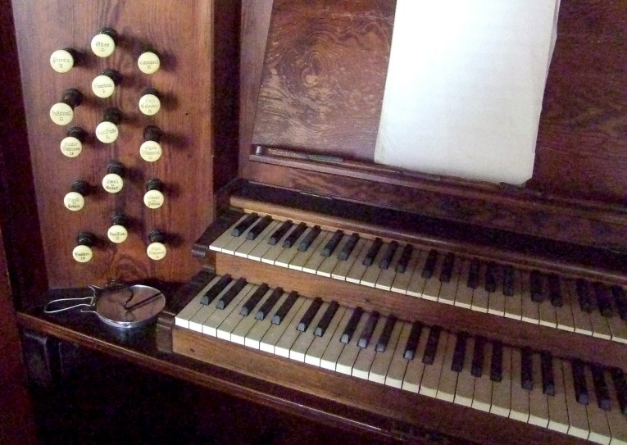
Open Diapason 16
Bourdon 16
Bass Flute 8

Great to Pedals
Swell to Pedals
Swell to Great

Parallel Flat pedal board
6 combination pedals

Central balanced swell pedal

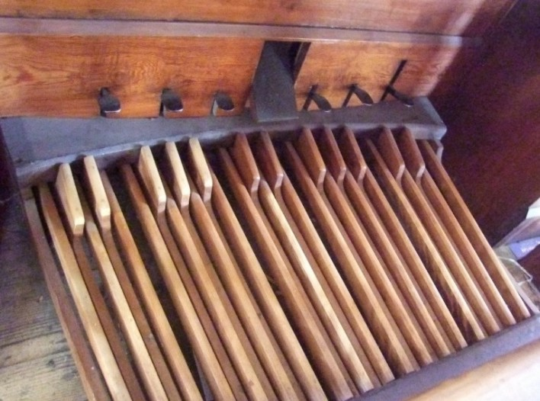
Pumping handle in place

Electric motor/blower

This well built, fine sounding instrument is a tribute to its builder. The organ demonstrates the skill and craftsmanship of a period of organ building that many current builders would be delighted to replicate.

It is well blest with stops at 8ft pitch, something of a rarity in modern organs as they are expensive to make.

What is particularly noticeable is the way that the stops blend, none dominating, all singing together. A beautiful sound.

The instrument is completely freestanding and accessible from all sides.

Sometime after its original construction a large pedal Open Diapason at 16ft pitch was added and this is in evidence when viewing the organ from the front. It is very well matched in to the organ and does not look out of place and is in keeping with the instrument.

With pneumatic action the organ has a light touch and has served the Church well for over 100 years. Sadly, the Church is now closed to Methodist worship and the instrument is redundant.

- From notes by Malcolm Starr

The organ is offered in whole and is immediately available.

Enquiries to the church contact, please.

Buyer makes all arrangements for its removal.

The Seller is not responsible for errors of information.

Organ Contact:
Malcolm Starr
Tel. 01400 281 291
Email: malcolmstarr@hotmail.com
Church Contact:
Rev. John P. Atkinson
Tel. 0292 051 2962
Email: john.atkinson@methodist.org.uk

